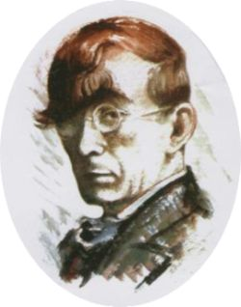 | ОСНОВНО УЧИЛИЩЕ „ГЕО МИЛЕВ”  4815,с.Грохотно,общ. Девин, обл.Смолян  е-mail: ou_gm_grohot@abv.bg Tel.0888 060934

MATHS
to Immigrants
GRADE: 3 /4/5
SUBJECTS: Immigration , Mathematics ,
TYPE: Lesson

MATHS, Social studies
Statue of Liberty Math The Statue of Liberty was a gift to the people of the United States from the people of France. The Statue of Liberty represents freedom to people all over the world.
The former immigration station at Ellis Island, along with the Statue of Liberty, comprise the Statue of Liberty National Monument.
Since 1884, millions of immigrants have passed by the Statue of Liberty. To many of these immigrants, it represented opportunity, the promise of a better life, and freedom. Use the facts and measurements below to find answers to the questions at the bottom of the page.
informaton | lenght | data
statue
pedestal
torch
hand
tablet width
tablet length
Right arm
steps in statue to torch
steps in pedestal
weight of copper skin
weight of steel frame
statue cost
pedestal cost
How old is it

Info
Information
Data statue pedestal torch length of hand length of right arm tablet width tablet length steps in statue to torch steps in pedestal weight of copper skin weight of steel frame statue cost pedestal cost
151 feet 1 inch (46. 05 m)
154 feet (47 m)
21 feet (6.3 m)
16 feet 5 inches (4.93 m)
42 feet (12.6 m)
13 feet 7 inches (4.1 m)
23 feet 7 inches (7.1 m)
Questions
1. What is the total height of the statue, from the base of the pedestal to the top of the torch?
2. What is the total weight of the statue?
3. How many steps are there in the Statue of Liberty?
4. What is the area in square inches (square meters) of the tablet’s surface?
5. How many inches (centimeters) taller than the statue is the pedestal?
6. What fraction of the total cost represents the cost of the statue?
7. About how many feet (meters) is it from the shoulder of the statue’s raised arm to the tip of her torch?

Answer Key to 7.
1. 305' 1" (92.99 m)
2. 225 tons (203 metric tons)
3. 338 steps 6. 5/12 or 4.7%
4. 46, 129 sq. in. (29 sq. cm)
5. 2' 11" (128 cm)
7. 80’ (24 m)

