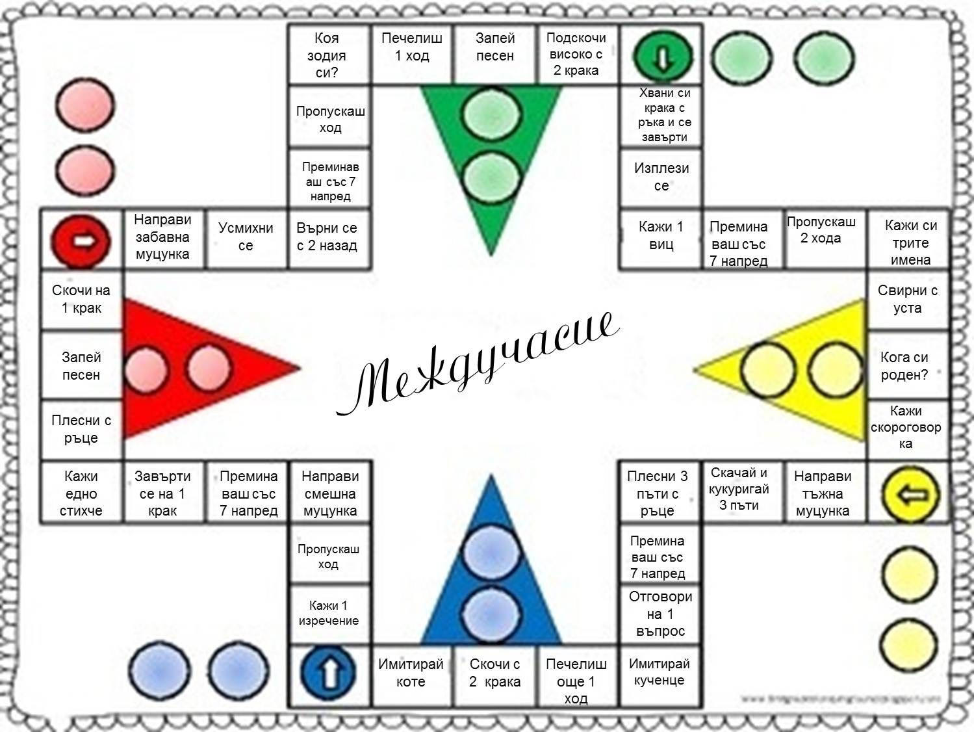
https://i.pinimg.com/originals/9e/32/82/9e328228b4c28bc879b644a51993d6cf.jpg?fbclid=IwAR1IkRQt611Bhe9iZumPmUG2W1NCIOOtY44iDO6zTQwSmKH4kw_8w0yCSKE

